Weston M. Stacey
Georgia Institute of Technology
Fusion Plasma Physics
Second, Revised and Enlarged Edition

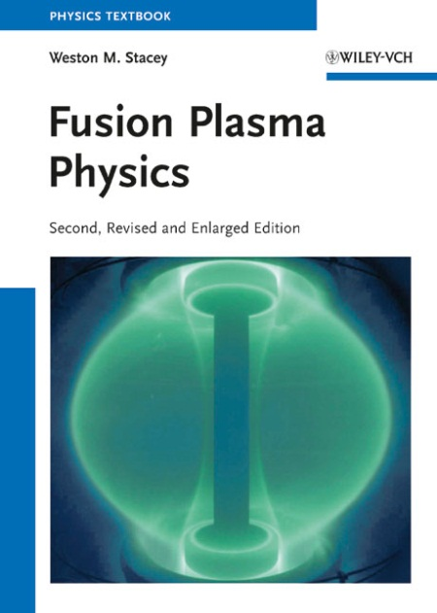

2012. XVIII, 648 pages with 191 figures 1 in color and 13 tables. Hardcover.
€ 99.-
ISBN: 978-3-527-41134-4

This revised and enlarged second edition of the popular textbook and reference contains comprehensive treatments of both the established foundations of magnetic fusion plasma physics and of the newly developing areas of active research. It concludes with a look ahead to fusion power reactors of the future. The well-established topics of fusion plasma physics -- basic plasma phenomena, Coulomb scattering, drifts of charged particles in magnetic and electric fields, plasma confinement by magnetic fields, kinetic and fluid collective plasma theories, plasma equilibria and flux surface geometry, plasma waves and instabilities, classical and neoclassical transport, plasma-materials interactions, radiation, etc. -- are fully developed from first principles through to the computational models employed in modern plasma physics.
The new and emerging topics of fusion plasma physics research -- fluctuation-driven plasma transport and gyrokinetic/gyrofluid computational methodology, the physics of the divertor, neutral atom recycling and transport, impurity ion transport, the physics of the plasma edge (diffusive and non-diffusive transport, MARFEs, ELMs, the L-H transition, thermal-radiative instabilities, shear suppression of transport, velocity spin-up), etc. -- are comprehensively developed and related to the experimental evidence. Operational limits on the performance of future fusion reactors are developed from plasma physics and engineering constraints, and conceptual designs of future fusion power reactors are discussed.

1. Basic Physics
2. Motion of Charged Particles
3. Magnetic Confinement
4. Kinetic Theory
5. Fluid Theory
6. Plasma Equilibria
7. Waves
8. Instabilities
9. Neoclassical Transport
10. Plasma Rotation
11. Turbulent Transport
12. Heating and Current Drive
13. Plasma-Material Interactions
14. Divertors
15. Plasma Edge
16. Neutral Particle Transport
17. Power Balance
18. Operational Limits
19. Fusion Reactors and Neutron Sources

Appendices
A: Frequently Used Physical Constants
B: Dimensions and Units
C: Vector Calculus
D: Curvilinear Coordinates
E: Plasma Formulas
F: Further Reading
G: Attributions
Yes, please send me the following title:

__ copies Stacey, W. M.
Fusion Plasma Physics
2nd updated and enlarged ed.
€ 99.-
ISBN: 978-3-527-41134-4

In EU countries the local VAT is effective. Postage will be charged. Due to fluctuating exchange rates, the prices for John Wiley & Sons’ titles are approximate. Prices are subject to change without notice. Our standard terms and delivery conditions apply. Date of information: 10/24/12

Please give credit card address if different from delivery address:

Street

Postcode, City
Thank you for your order.

Please pass this order form to your local bookseller

or to:

Wiley-VCH
P.O. Box 10 11 61, 69451 Weinheim, Germany
Tel. +49 (0) 62 01-60 64 00
Fax +49 (0) 62 01-60 61 84
e-mail: service@wiley-vch.de
Visit us at http://www.wiley-vch.de/

Register now for the free
Wiley-VCH Alerting Service!
http://www.wiley-vch.de/home/pas

Delivery and Invoice address:

__ private __ business

Surname, First Name

Firm/Institution

Department

Street/P.O. Box

Country, Postcode, City

VAT No.*

Tel.

Fax

e-mail

Date, Signature
Please keep me informed of new publications in the subject areas:
Plasma Physics (PH70)
Nuclear & High Energy Physics (PH20)
Power Technology & Power Engineering (PH20)

*: If you would like the invoice to be addressed to your company, please include your VAT number so that we can process your order quickly and competently.

